

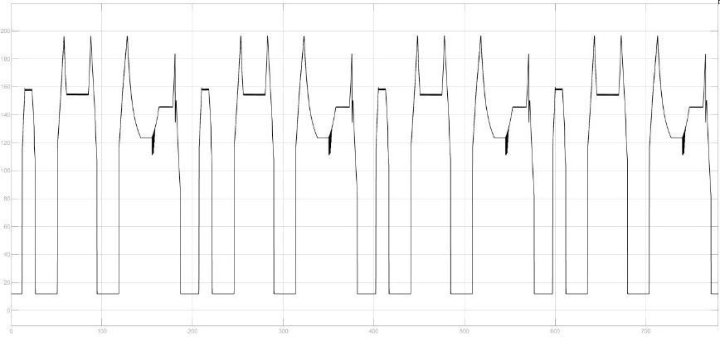

Figure n (Safe Discharge Current)

### 2.2 Vehicle Discharge Cycle Performance

To simulate car Discharge current 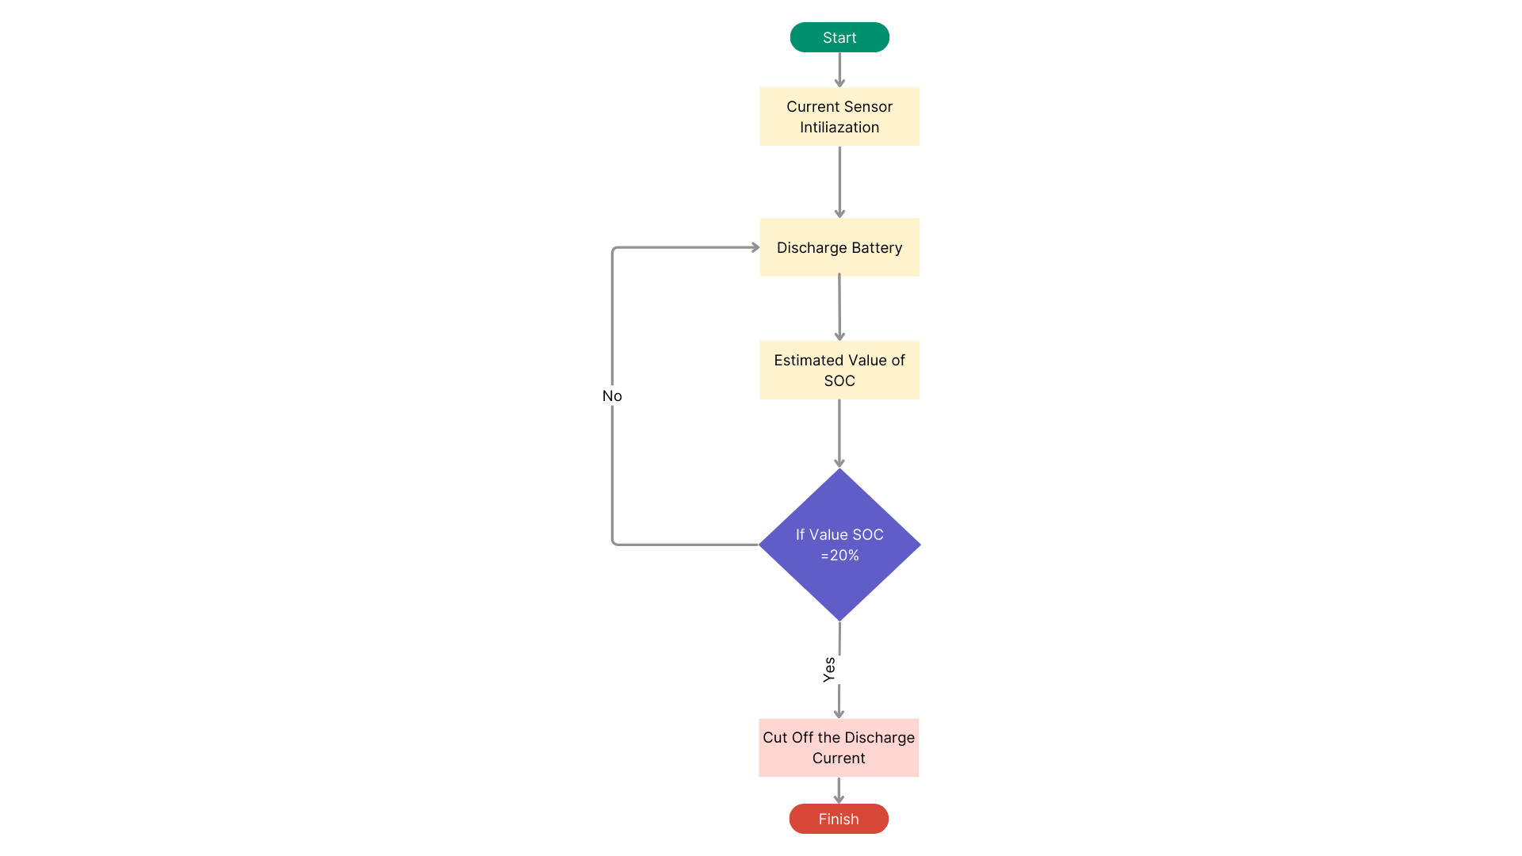

### Discharge current of Battery

To ensure the protection of the discharge current of electric vehicles and safeguard the Battery Management System (BMS), employing graphs can elucidate the safe discharge limits and facilitate efficient monitoring.

Graph n illustrates the Safe Discharge Current relative to BMS thresholds.

It plots the relationship between the discharge current and the corresponding BMS safety limits, providing a visual reference for maintaining optimal discharge levels without jeopardizing battery health.

In graph (n+1), a flowchart depicts the Discharge Cycle, delineating the sequence of steps involved in regulating the discharge process.

This flowchart outlines the decision-making pathways for managing discharge currents within safe parameters, integrating considerations such as battery capacity, temperature, and load demand.

It's imperative to ensure that the discharge current remains below 200 A to prevent overloading and potential damage to the battery system.

Exceeding this threshold can lead to overheating, accelerated degradation, and safety hazards.

By adhering to this safe current limit, electric vehicle operators can prolong battery lifespan, optimize performance, and mitigate risks associated with excessive discharge rates, thereby enhancing the overall reliability and longevity of the vehicle's power supply system.

Figure n+1 (Discharge cycle)

